e-PU10 V2
Passive Gas Venting Calculations
Corrected Multi-Gas Pressure Model

Engineering Calculation Report - Revision 2 (updated model)
Subject: Thermal runaway gas venting assessment of the e-PU10 container
Document type: Design review calculation report

This revision corrects the pressure calculation of the earlier updated model. Previously the internal pressure build-up was computed from the hydrogen release only. Thermal runaway, however, releases several gases (H₂, CO₂, CO and hydrocarbons) that all contribute to the total number of gas molecules and therefore to the pressure. The pressure balance now includes all released gases, while the hydrogen concentration – which governs the explosion risk – continues to be evaluated from hydrogen alone.

1 Introduction
This document presents the corrected calculations used to assess the passive gas-venting safety of the e-PU10 battery container during a cell or module thermal runaway. When a battery cell enters thermal runaway it releases a large volume of hot, flammable and toxic vent gas over a short time. Inside the closed e-PU10 container (free volume 8.067 m³) this creates two coupled hazards that must both be controlled by design: a rise in flammable-gas concentration and a rise in internal pressure.
The hazards evaluated are:
- Hydrogen explosion risk – hydrogen has the widest flammability range and the lowest ignition energy of the vented species, so it governs the flammable-gas hazard. A conservative working limit of 25% of the LEL is applied: C_H2 < 1 %vol.
- Pressure build-up (overpressure) – the sudden release of all gas species raises the internal pressure; if the container cannot relieve this pressure it may be structurally damaged. All released gases contribute to this pressure, not hydrogen alone.
Passive venting is investigated because it has no moving parts, requires no power, cannot fail to start, and is therefore inherently more reliable during a fault condition than an active fan. The purpose of this report is to determine the minimum passive vent area that keeps the hydrogen concentration below 1 %vol throughout the release while safely relieving the pressure produced by the complete gas mixture.
Correction in this revision: the previous updated model sized the vent on a pressure build-up computed from hydrogen only. That underestimates the true pressure, because CO₂, CO and hydrocarbons also add molecules to the container. Including all gases raises the internal pressure, increases the pressure difference across the vent, and therefore increases the pressure-driven venting flow. The net effect is that the same hydrogen-concentration limit is met with a smaller vent area than previously calculated.

2 Gas release composition
The gas release data are taken from the UL 9540A module report (“4790880512-UL 9540A Module Report-final version.pdf”). Hydrogen is supplied to the model as a measured time-dependent volumetric flow profile (H2_profile.csv); the total hydrogen volume released over the event is 0.2428 m³ (242.8 L). The additional gas volumes released during the same event are listed below. CO₂, CO and hydrocarbons are assumed to follow exactly the same time-dependent release profile as hydrogen.
Gas | Release volume | Used for H₂ concentration | Used for pressure
H₂ (hydrogen) | 0.2428 m³ (242.8 L) | Yes | Yes
CO₂ (carbon dioxide) | 0.07875 m³ (78.75 L) | No | Yes
CO (carbon monoxide) | 0.24640 m³ (246.40 L) | No | Yes
HC (total hydrocarbons) | 0.26195 m³ (261.95 L) | No | Yes
Total | 0.8299 m³ (829.9 L) | H₂ only | All species
Table 1 Gas release composition and its use in the two calculations.
Why the gases are treated differently:
The hydrogen concentration is the explosion criterion. Hydrogen is the critical flammable species, so only hydrogen is counted when checking C_H2 < 1 %vol; adding the other gases to the hydrogen concentration would be physically wrong and would misstate the flammability margin. The pressure, in contrast, is a property of the total gas quantity: every molecule of H₂, CO₂, CO and HC occupies the same container and pushes on its walls, so all species must be included in the pressure (ideal-gas) balance. Because CO₂, CO and HC together add about 2.4 times the hydrogen volume, the total generated gas volume is about 3.42 times the hydrogen volume (gas factor = 3.4185), which is exactly the factor by which the pressure source term is increased relative to the hydrogen-only model.

3 Calculation methodology
The model integrates the coupled gas balance forward in time with a fixed step Δt = 1 s. At each step it evaluates: (i) the internal pressure and the pressure difference across the opening, (ii) the pressure-driven vent flow, (iii) the diffusive exchange flow, (iv) the hydrogen mass balance and concentration, and (v) the updated internal pressure from the total-gas ideal-gas law.

3.1 Gas generation
Hydrogen generation is the prescribed source term S(t) [m³/s] from the measured profile:
$$\frac{dV_{H2}}{dt} = S(t)$$
CO₂, CO and HC share the hydrogen release shape, so the total (all-species) generation rate is the hydrogen rate scaled by the ratio of total released volume to hydrogen volume:
$$gas_{factor}=\frac{V_{H2}+ V_{CO2}+ V_{CO}+ V_{HC}}{V_{H2}} = 3.4185$$
$$S_{total}(t) = gas_{factor} · S(t)$$

3.2 Total gas balance and pressure (ideal gas law)
The internal pressure follows from the ideal-gas law applied to the total gas amount:
$$P · V = n_{total} · R · T ,$$
$$n_{total} = n_{H2} + n_{CO2} + n_{CO} + n_{HC} + n_{air}$$
The initial gas charge (air) is n_initial = P_atm·V/(R·T). The excess moles accumulate the balance between total gas generated and gas expelled by the pressure-driven vent flow:
$$n_{generated} = S_{total}\left(t\right)·\frac{P_{atm}}{R·T}$$
$$n_{removed} = Q_{pressure} ·\frac{P_{inside}}{R·T}$$
$$n_{extra} ← max\left( n_{extra} + \left(n_{generated} - n_{removed}\right)·Δt , 0\right)$$
$$P_{inside} = \left(n_{initial} + n_{extra}\right)· R ·\frac{T}{V}$$
Only the pressure-driven flow removes net moles; the diffusive exchange is bidirectional and does not represent net expulsion.

3.3 Hydrogen concentration (H₂ only)
Hydrogen mixes instantaneously and uniformly. Its volume fraction uses hydrogen alone:
$$C_{H2}=\frac{V_{H2}}{V_{container}}$$
$$C_H2[i] = max\left( C_{H2}\left[i-1\right]+\frac{ S\left(t\right)·Δt - C_{H2}\left[i-1\right]·Q_{total}·Δt }{V_{container}} , 0 \right)$$
CO₂, CO and HC are deliberately excluded from this equation.

3.4 Vent flow calculation (sharp-edged orifice)
The opening is a sharp-edged circular hole; the small ΔP keeps the flow incompressible, so the orifice (Bernoulli) equation applies:
$$Q = C_{d} · A · \sqrt{ 2·\frac{ΔP}{ρ}}$$
- Q = volumetric flow through the opening [m³/s]
- C_d = 0.65, discharge coefficient of a sharp-edged hole [–]
- A = vent opening area [m²]
- ΔP = P_inside − P_atm, pressure difference [Pa] (floored at 0)
- ρ = 1.2 kg/m³, gas density used in the orifice equation
Because the multi-gas model produces a higher ΔP than the hydrogen-only model, the pressure-driven flow Q is larger, which improves passive venting.

3.5 Gas exchange with outside air
Even without a pressure difference, gas is exchanged across the opening (hydrogen out, fresh air in). This buoyancy/diffusion exchange is modelled proportional to the opening area:
$$Q_{diff} = k_{diff} · A , k_{diff} = 0.15 m³/s per m²$$
$$Q_{total} = Q_{pressure} + Q_{diff}$$
The diffusive exchange is the dominant concentration-reduction mechanism once the pressure transient decays, continuously replacing hydrogen-laden air with clean external air.

4 Assumptions
Assumption | Explanation
Instantaneous mixing | Conservative, simplified uniform gas distribution in the 8.067 m³ volume
Constant temperature (293 K) | Ideal-gas approximation; hot vent gas addressed as a limitation
Ideal gas behaviour | Used for the total-gas pressure calculation (PV = nRT)
Sharp-edged circular vent | Used for the orifice flow equation with C_d = 0.65
Passive ventilation | No fan assistance; flow driven only by pressure and diffusion
Same release profile | CO₂, CO and HC follow the H₂ time-dependent release profile
All gases in pressure | H₂+CO₂+CO+HC all add molecules and contribute to pressure
H₂ only in concentration | Only hydrogen governs the explosion criterion (C_H2 < 1 %vol)
Constant density (1.2 kg/m³) | Fixed value required for the orifice flow calculation
Incompressible flow | Justified because ΔP stays far below the choking threshold
Quiescent external air | Standard air at P_atm, T outside the container
Container volume 8.067 m³ | Given design value from the e-PU10 volume model
Table 2 Model assumptions.

5 Python model (gasventing.py)
The calculation is implemented in gasventing.py (NumPy / pandas / matplotlib). The script reads the hydrogen generation profile, derives the total-gas generation rate from the release composition, runs the time-stepping simulation for a set of candidate vent areas, and plots the hydrogen concentration and pressure histories.
Variable | Unit | Initial value | Description
V_con | m³ | 8.067 | Free container volume
dt | s | 1.0 | Simulation time step
Cd | – | 0.65 | Orifice discharge coefficient
rho | kg/m³ | 1.2 | Gas density used in the orifice equation
P_atm | Pa | 101325 | Atmospheric (reference) pressure
T | K | 293 | Constant gas temperature
R | J/(mol·K) | 8.314 | Universal gas constant
k_diff | m³/s per m² | 0.15 | Diffusion/exchange coefficient per unit area
H2_gen | m³/s | from CSV | Hydrogen generation rate S(t)
V_H2_total | m³ | 0.2428 | Total hydrogen volume released
V_CO2 / V_CO / V_HC | m³ | 0.07875 / 0.24640 / 0.26195 | Additional released gas volumes
gas_factor | – | 3.4185 | Ratio of total gas volume to hydrogen volume
total_gen | m³/s | H2_gen·gas_factor | Total (all-species) generation rate for pressure
areas | m² | [0,0.01,0.02,0.03,  0.04,0.05,0.06,0.08] | Candidate vent areas compared
CH2 | – | 0 | Hydrogen volume fraction history
P_inside | Pa | P_atm | Internal pressure history
n_initial | mol | P_atm·V/(R·T) | Initial moles of air in the container
n_extra | mol | 0 | Accumulated excess moles above the initial charge
deltaP | Pa | computed | Pressure difference across the opening (≥0)
Q_pressure | m³/s | computed | Pressure-driven orifice flow
Q_diff | m³/s | computed | Diffusive/exchange flow (k_diff·A)
Q_total | m³/s | computed | Total exchange flow (Q_pressure + Q_diff)
n_generated | mol/s | total_gen·P_atm/(R·T) | Total moles generated in the step (all gases)
n_removed | mol/s | Q_pressure·P/(R·T) | Moles expelled by the pressure-driven flow
Table 3 Variables in gasventing.py.

5.1 Timestep calculation
- Add gas generation – read the hydrogen rate S(t) and form the total-gas rate S_total(t) = gas_factor·S(t).
- Calculate total gas amount – convert the total generation to moles n_generated and accumulate n_extra.
- Calculate pressure – P_inside = (n_initial + n_extra)·R·T/V, giving ΔP = P_inside − P_atm.
- Calculate pressure-driven vent flow – Q_pressure = C_d·A·√(2·ΔP/ρ); add Q_diff = k_diff·A to get Q_total.
- Remove gases through the vent – subtract n_removed = Q_pressure·P_inside/(R·T) from the pressure balance.
- Calculate hydrogen concentration – update C_H2 from hydrogen generated minus hydrogen removed (C_H2·Q_total), H₂ only.
- Continue simulation – advance to the next step and store the histories once the area is complete.

6 Results
The simulation was run for the candidate vent areas with the corrected multi-gas pressure model. Figure 1 shows the hydrogen concentration, Figure 2 the internal pressure rise, and Figure 3 compares the sealed-container pressure of the hydrogen-only and multi-gas models. Table 4 summarises the peak values.
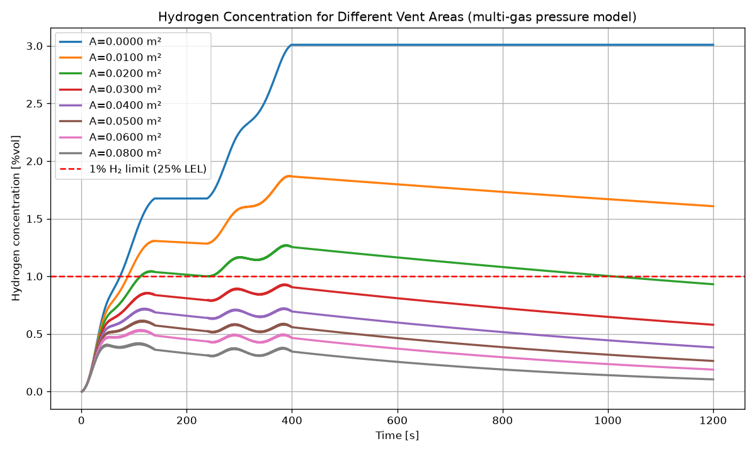
Figure 1 Hydrogen concentration vs time for different vent areas (multi-gas pressure model). Dashed red line = 1 %vol (25% LEL) limit.
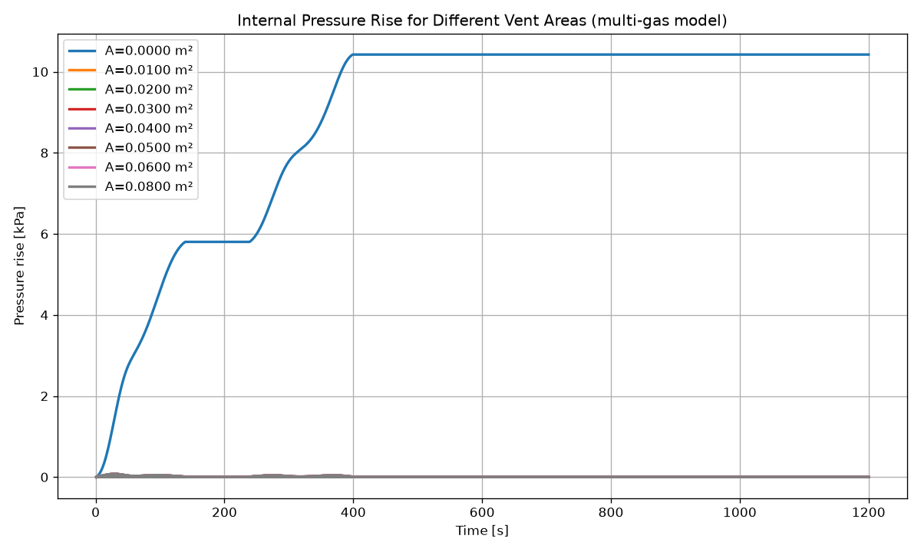
Figure 2 Internal pressure rise vs time for different vent areas (multi-gas model).
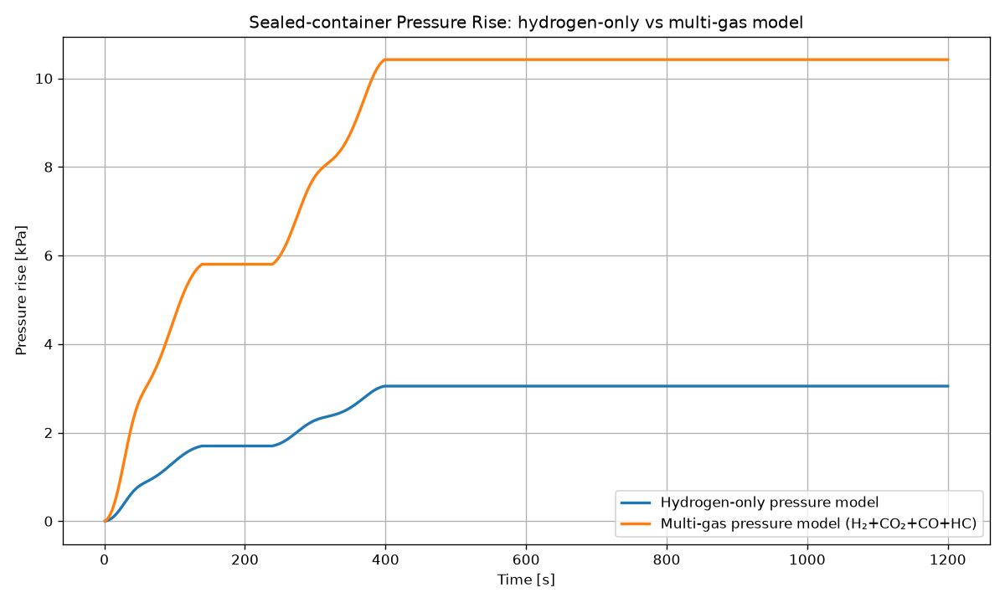
Figure 3 Sealed-container pressure rise: hydrogen-only model (3.05 kPa) vs corrected multi-gas model (10.42 kPa).

Vent area A [m²] | Peak H₂ concentration [%vol] | Peak pressure rise [kPa] | Below 1% limit?
0.00 (sealed) | 3.01 | 10.42 | No
0.01 | 1.87 | 0.079 | No
0.02 | 1.27 | 0.079 | No
0.03 | 0.93 | 0.079 | Yes
0.04 | 0.72 | 0.079 | Yes
0.05 | 0.62 | 0.079 | Yes
0.06 | 0.54 | 0.079 | Yes
0.08 | 0.42 | 0.079 | Yes
Table 4 Peak hydrogen concentration and pressure rise per vent area (multi-gas model).

6.1 Hydrogen-only vs multi-gas pressure model
In the sealed case the corrected multi-gas model raises the peak pressure from 3.05 kPa (hydrogen-only) to 10.42 kPa – a factor of 3.42, exactly the gas factor, confirming the correction. Once a finite opening is present the peak pressure collapses to a small value in both models (about 79 Pa in the multi-gas model vs 23 Pa hydrogen-only), because even a small orifice vents the gas at a low pressure difference. The higher ΔP in the multi-gas model produces a larger pressure-driven flow, which also helps remove hydrogen. As a result the hydrogen concentration for a given area is lower than in the hydrogen-only model, and the 1 %vol limit is met at a smaller vent area.

6.2 New required vent area
With the corrected model the smallest studied area that keeps the peak hydrogen concentration below 1 %vol is 0.03 m² (0.93 %vol). The threshold is crossed at about A ≈ 0.028 m². A vent area of 0.03 m² is therefore recommended, replacing the previous 0.05 m². This is a 40% reduction in required area, driven by the additional pressure-driven venting from the full gas mixture.
Model | Required vent area
Previous hydrogen-only pressure model | 0.05 m²
Updated multi-gas pressure model | 0.03 m²
Table 5 Required vent area: hydrogen-only vs corrected multi-gas model.

7 Practical venting solutions
The validated model shows that a net free vent area of 0.03 m² keeps the hydrogen concentration below the 1 %vol design limit throughout the release. A permanently open hole of this size is, however, undesirable in service because it admits dust, dirt, insects and water into the container. This section evaluates three practical ways of providing the required venting duty and selects the most suitable for the e-PU10:
- Option 1 – Open vent area: the existing 0.03 m² louvred opening.
- Option 2 – G4 air filter (EN 779 classification, or the equivalent ISO 16890 coarse filter).
- Option 3 – Overpressure (pressure-relief) valve instead of a permanently open vent.
Governing venting duty. The peak hydrogen concentration is set almost entirely by the pressure-driven exchange during the release peak at t ≈ 29 s. At that instant the open 0.03 m² vent passes a peak flow of about 0.223 m³/s at a pressure difference of only ≈ 79 Pa (peak face velocity ≈ 7.4 m/s). A supplementary run of the validated model with the pressure-driven flow suppressed (diffusion exchange only, Q_diff = k_diff·A) gives a peak concentration of 2.67 %vol; the diffusive term therefore only flushes the container after the event and cannot by itself hold the 1 %vol limit. Any practical solution must preserve this low-pressure, high-flow exchange capacity during the transient. This is the criterion against which the three options are sized below.

7.1 Option 1 – Open vent area (baseline)
A passive vent opening with a minimum net free area of 0.03 m² is recommended for the e-PU10 container. A modest margin (towards ~0.04 m² of net free area) is advisable to cover manufacturing tolerance, partial blockage and modelling uncertainty. A circular hole of 0.03 m² corresponds to a diameter of about 0.195 m (Ø ≈ 195 mm); the same area may be distributed over several smaller openings. Because hydrogen is buoyant, the vent(s) should be placed high on the enclosure. The quoted area is the net effective (open) area after any grille, mesh or membrane is accounted for.
Why Option 1 requires the smallest area. An open sharp-edged orifice has the lowest possible flow resistance (discharge coefficient C_d ≈ 0.65 and no added media). For a given pressure difference it therefore passes the largest flow and reaches the 1 %vol limit with the smallest geometric area (0.03 m²; threshold ≈ 0.028 m²). Every element added in the flow path (louvre, mesh, filter or valve) increases resistance and requires a correspondingly larger physical opening to preserve the same net effective flow.
Advantages of Option 1:
- Lowest flow resistance, hence the smallest required area (0.03 m²).
- No moving parts, no power, cannot fail to open – inherently reliable during a fault.
- Negligible internal pressure rise (≈ 79 Pa).
- Lowest cost and effectively maintenance-free.
Disadvantages of Option 1:
- No protection against dust, dirt, insects or water ingress.
- Open path for external ignition (a flame arrestor must be added).
- Weather protection and any mesh reduce the net effective area, so the physical opening must be enlarged to preserve 0.03 m² net.

7.2 Option 2 – G4 air filter (EN 779 / ISO 16890 coarse)
A G4 coarse filter mounted in the vent keeps dust, dirt and insects out while still allowing gas exchange. Because a fibrous filter adds flow resistance, the vent face area must be enlarged so that the effective airflow keeps the hydrogen concentration below 1 %vol even when the filter is dirty (end of life).
Researched filter resistance (typical G4 panel data):
- Reference filter: a standard 592 × 592 mm G4 panel rated at ≈ 3400 m³/h (≈ 0.94 m³/s), i.e. a rated face velocity v_rated ≈ 2.7 m/s (representative Camfil / MANN+HUMMEL / AAF / Freudenberg data).
- Clean (initial) pressure drop: ΔP_clean ≈ 45–65 Pa at v_rated; a value of 55 Pa is used.
- Dirty / end-of-life pressure drop: ΔP_dirty = 250 Pa, the recommended final pressure drop for coarse/medium filters in EN 779:2012.
Filter resistance model. At the low velocities of passive venting the filter behaves as a viscous (Darcy) resistance, $ΔP_{filter} = k_{f}·v$, where $v =\frac{Q}{A}$ _f is the face velocity and $A_{f}$ the filter face area. From the datasheet points: k_clean = 55 Pa / 2.7 m/s ≈ 20 Pa·s/m and k_dirty = 250 Pa / 2.7 m/s ≈ 93 Pa·s/m.
Combined flow path. The filter is placed in series with the opening, so the driving pressure splits between the orifice loss and the filter loss: $ΔP = \left(\frac{ρ}{2}\right)·{\left(\frac{v}{C_{d}}\right)}^{2}+ k_{f}·v$. For a given ΔP this quadratic is solved for the face velocity v, giving the flow $Q = v·A_{f}$. This resistance is inserted into the validated time-stepping model in place of the plain orifice, and the minimum filter face area that keeps the peak hydrogen concentration below 1 %vol is found for the clean and the dirty condition. Setting k_f = 0 reproduces the open-vent threshold of 0.028 m² (Section 6), which validates the extended model.
Calculated required filter face area:
- Clean filter (k_f ≈ 20 Pa·s/m): A_f ≥ 0.078 m² (Ø ≈ 314 mm).
- Dirty / end-of-life filter (k_f ≈ 93 Pa·s/m, worst case, governs): A_f ≥ 0.193 m² (Ø ≈ 496 mm).
Safety factor. A safety factor of 1.5 is recommended on the end-of-life area to cover manufacturing tolerance, non-uniform dust loading and local blockage, hydrogen stratification, and the spread in published filter data: A_f,design = 1.5 × 0.193 ≈ 0.29 m².
Practical selection. One standard 592 × 592 mm G4 panel provides ≈ 0.30 m² of net media face (Ø-equivalent ≈ 0.62 m), which satisfies the requirement. At this size the peak face velocity is only ≈ 0.84 m/s when dirty and ≈ 3.2 m/s when clean, and the model gives a peak hydrogen concentration of 0.73 %vol (dirty) and 0.31 %vol (clean) – both comfortably below the 1 %vol limit.
Table 7 G4 filter sizing (series orifice + Darcy-resistance model).
Condition | Required net face area [m²] | Equivalent diameter [mm] | Peak face velocity [m/s] | Peak H₂ concentration [%vol]
Clean (initial), k_f ≈ 20 Pa·s/m | 0.078 | 314 | 3.16 | 1.00
Dirty / end-of-life, k_f ≈ 93 Pa·s/m (governs) | 0.193 | 496 | 0.84 | 1.00
Recommended design (0.30 m², SF = 1.5 on EOL) | 0.30 | 618 | 0.84 (dirty) / 3.16 (clean) | 0.73 (dirty) / 0.31 (clean)

Key assumptions for Option 2:
- Filter pressure drop is linear in face velocity (Darcy regime), valid at the low velocities involved.
- Filter and opening act in series; the diffusive exchange term $k_{diff}·A$ is retained on the filter face (a conservative treatment, since a loaded filter would further suppress it, but diffusion does not govern the peak).
- End-of-life resistance equals the EN 779 recommended final pressure drop of 250 Pa.
- Clean and end-of-life data are representative of the G4 class; the selected product datasheet should be confirmed.
Advantages of Option 2:
- Keeps out dust, dirt and insects, and (with a hood) protects against splashing water.
- Fully passive – no moving parts and no power required.
- Maintains a defined, verifiable net area when serviced; loading can be monitored via a ΔP gauge or loading indicator.
Disadvantages of Option 2:
- Much larger face area than the open vent (≈ 0.30 m², roughly 10× the 0.03 m² open area).
- Resistance rises as the filter loads, so it must be sized on the end-of-life condition.
- Requires periodic inspection and replacement (recurring maintenance and cost).
- Can blind with water or ice and lose venting capacity if not weather-protected and drained.

7.3 Option 3 – Overpressure (pressure-relief) valve
An overpressure relief valve is a spring-, weight- or magnet-loaded flap or poppet that stays closed – sealing the enclosure against dust and water – until the internal pressure exceeds a set cracking pressure, at which point it lifts to vent and then recloses when the pressure falls. When shut it can provide an IP-rated seal, giving the best ingress protection of the three options. Such valves and vent dampers are used on BESS enclosures for overpressure and deflagration relief (NFPA 68 / EN 14994; see also NFPA 855 and IEC 62933-5-2).
Typical opening (cracking) pressures:
- Low-pressure tank / enclosure relief valves: ≈ 5–70 mbar (≈ 500–7000 Pa) – e.g. API 2000 / EN ISO 28300 practice.
- Explosion-relief panels / dampers for BESS enclosures: commonly ≈ 10–100 mbar (≈ 1–10 kPa).
When it opens during this release. The valve opens only once the internal pressure exceeds its set point. In this event the open-vent pressure is only ≈ 79 Pa, and even the fully sealed container peaks at 10.42 kPa (Section 6). A valve set at any realistic value (several hundred Pa or more) therefore stays shut during the low-pressure dilution phase, when venting is most needed.
Capacity check. The validated model was re-run with the valve represented as an orifice that flows only while ΔP exceeds the cracking pressure P_crack. The results show that the hydrogen limit is met only for an unrealistically low set point combined with a large valve, and is otherwise exceeded by a factor of about two to three:
Table 8 Overpressure-valve capacity check (valve flows only while ΔP > P_crack).
Cracking pressure P_crack [Pa] | Valve open area [m²] | Peak H₂ concentration [%vol] | Peak internal pressure rise [Pa]
100 | 0.10 | 0.95 | 157
200 | 0.03 | 2.38 | 263
500 | 0.03 | 2.66 | 575
1000 | 0.03 | 2.84 | 1050
5000 | 0.03 | 2.89 | 5039

Interpretation. Because the thermal-runaway release is a low-pressure, dilution-limited event – not an overpressure event – a pressure-relief valve set at realistic cracking pressures does not open early enough to hold the hydrogen concentration below 1 %vol, and so cannot serve as the primary hydrogen-dilution vent. It is, however, well suited as supplementary deflagration / overpressure protection (sized per NFPA 68 / EN 14994) to protect the enclosure structure against a fast pressure rise, and it offers the best dust and water protection when shut. For that supplementary duty the valve does not govern: at the peak total-gas generation of only ≈ 6.3 L/s the modest ΔP is relieved by even a small valve.
Advantages of Option 3:
- Best protection against dust, insects and water – sealed (IP-rated) when closed, with no open path.
- No filter media to replace; low routine maintenance (periodic function test only).
- Recloses automatically; well suited to overpressure / deflagration protection of the enclosure.
Disadvantages of Option 3:
- Cracking pressure (hundreds of Pa to several kPa) far exceeds the ≈ 79 Pa the release generates.
- Provides no venting until the set point is reached, so hydrogen exceeds 1 %vol – unsuitable as the sole/primary vent.
- Has moving parts that can stick or corrode and fail to open, so periodic testing is required.

7.4 Comparison and final recommendation
Table 9 compares the three options against the criteria relevant to the e-PU10 container. The open vent defines the minimum area and the lowest resistance; the G4 filter meets the hydrogen limit while protecting against ingress; the overpressure valve protects against ingress but cannot meet the hydrogen limit on its own.
Table 9 Comparison of the three venting solutions for the e-PU10 container.
Criterion | Option 1 – Open vent | Option 2 – G4 filter | Option 3 – Overpressure valve
Required size (net) | 0.03 m² (Ø 195 mm); margin to 0.04 m² | ≈ 0.30 m² net media (one 592×592 mm G4; SF 1.5 on 0.193 m² EOL) | n/a for dilution (set point ≫ 79 Pa)
Airflow resistance | Lowest (orifice only, ≈ 79 Pa peak) | Moderate–high; rises with loading, sized for 250 Pa EOL | Very high until cracked; then low
Hydrogen safety (peak C_H2) | 0.93 %vol – PASS | 0.73 %vol dirty / 0.31 %vol clean – PASS | 2.1–2.8 %vol – FAIL as primary vent
Dust / water protection | None (needs louvre / hood) | Good dust & insect + splash (with hood) | Best (sealed when closed)
Maintenance | Effectively none | Periodic inspection / replacement | Periodic function test
Reliability | Highest (no moving parts) | High if serviced; degrades as it loads | Mechanical parts can stick / fail to open
Cost implications | Lowest | Moderate (filter, housing, servicing) | Moderate (mechanical device)
Suitability for e-PU10 | Meets safety but poor ingress protection | Recommended primary solution | Supplementary overpressure / deflagration device only

Engineering recommendation.
- Adopt a G4-filtered passive vent as the primary solution: a high-mounted, weather-hooded G4 (EN 779 / ISO 16890 coarse) filter panel with a net media face area of at least 0.29 m² – conveniently one standard 592 × 592 mm G4 panel (≈ 0.30 m² net) – sized on the end-of-life (250 Pa) resistance with a 1.5 safety factor. This holds the peak hydrogen concentration at ≈ 0.73 %vol even with a fully loaded filter while protecting the container against dust, dirt, insects and splashing water.
- The open 0.03 m² vent remains the reference minimum net free area and the lowest-resistance option, but is not recommended for service use because it offers no ingress protection.
- A pressure-relief / overpressure valve is not suitable as the primary vent, because its cracking pressure (hundreds of Pa to several kPa) greatly exceeds the ≈ 79 Pa generated by the release; it would not open in time to hold the 1 %vol limit. It is recommended only as a supplementary deflagration / overpressure device (NFPA 68 / EN 14994) and for its superior sealing when closed.
Implementation notes:
- Mount the vent high on the enclosure (hydrogen is buoyant) and fit a downward-facing weather hood with drainage.
- Prefer inorganic / metal (non-combustible) G4 media near the BESS and add a flame arrestor at the opening.
- Monitor filter loading (ΔP gauge or indicator) and schedule inspection / replacement before the end-of-life pressure drop is reached.
References and standards used in this assessment:
- EN 779:2012 – Particulate air filters for general ventilation: G1–G4 / M / F classification and recommended final pressure drop (250 Pa for coarse/medium classes).
- ISO 16890-1:2016 – Air filters for general ventilation: classification (ISO Coarse ≈ former G4).
- Eurovent 4/21 (4/23) – energy classification and typical initial pressure drop of G4 panel filters.
- Representative manufacturer data – Camfil (30/30), MANN+HUMMEL, AAF, Freudenberg Viledon G4 panels: 592×592 mm, ≈ 3400 m³/h, initial ΔP ≈ 45–65 Pa, final ΔP 250 Pa (values to be confirmed against the selected datasheet).
- API Standard 2000 / EN ISO 28300 – venting of low-pressure tanks (relief-valve set pressures); EN ISO 4126 – safety devices against excessive pressure.
- NFPA 68 / EN 14994 – deflagration (explosion) venting; NFPA 855, IEC 62933-5-2, UL 9540A – BESS safety; NFPA 2 / ISO/TR 15916 – hydrogen safety (H₂ LEL 4 %vol; 1 %vol = 25 % LEL).

8 Critical engineering review
Mathematical correctness:
- Sealed-case mass-balance check: the multi-gas plateau pressure (10.42 kPa) equals the hydrogen-only value (3.05 kPa) times the gas factor (3.4185), and the hydrogen plateau concentration (3.01 %vol) equals 0.2428 m³ ÷ 8.067 m³ = 3.01 %vol. Both balances are internally consistent.
- Flow regime: peak ΔP is ~79 Pa, far below the compressibility/choking threshold, so the incompressible orifice equation is valid.
- Separation of concerns: pressure uses total moles (all species); hydrogen concentration uses hydrogen only – the physically correct treatment for each quantity.
Is the approach conservative?
Yes. Including all gases in the pressure calculation while evaluating only hydrogen for the flammability limit is a conservative vent-sizing approach. The extra CO₂, CO and HC increase the internal pressure and hence the pressure-driven venting; if these gases were (wrongly) ignored in the pressure balance, the model would predict less venting and would therefore demand a larger vent area. By crediting the additional pressure but not diluting the hydrogen criterion with non-hydrogen gases, the model neither over-credits the flammability margin nor under-credits the pressure relief. The resulting 0.03 m² is a safe (if anything, generous) requirement for the hydrogen limit.
Remaining uncertainties and possible improvements:
- Real gas-mixture properties – the orifice density (1.2 kg/m³) and ideal-gas assumption are approximations; the true mixture is lighter and hotter. Using real mixture density would mainly affect the (already tiny) pressure-driven flow, not the conclusion.
- Transient temperature effects – hot vent gas raises pressure and buoyancy transiently; higher buoyancy aids diffusive venting, while higher temperature raises pressure. Given the small computed ΔP, the net effect on required area is minor but should be confirmed.
- Compressible flow – not required here (ΔP ≪ choking threshold), but a check at the peak instant confirms incompressible flow is adequate.
- Non-uniform mixing – the well-mixed assumption can under-predict local hydrogen pockets near the source and ceiling; this is the most important limitation and is mitigated by design margin and high vent placement. CFD verification is recommended.
- Real vent-component behaviour – louvres, membranes, filters and arrestors reduce the effective C_d/area; the physical opening must be enlarged to preserve 0.03 m² net area.
- Empirical diffusion coefficient – k_diff = 0.15 m³/s per m² directly drives the concentration decay and should be validated against CFD or test data.
None of these effects overturns the conclusion: the pressure hazard is comfortably relieved by any modest opening, and a passive area of about 0.03 m² keeps the bulk hydrogen concentration below 1 %vol throughout the release.

9 Conclusion
The corrected multi-gas model gives the following conclusions:
- Correction: the pressure build-up now includes all released gases (H₂, CO₂, CO, HC), raising the sealed-container pressure from 3.05 kPa to 10.42 kPa (gas factor 3.4185). Hydrogen alone is still used for the explosion-concentration criterion.
- Required passive vent area: approximately 0.03 m² of net free area keeps the peak hydrogen concentration below the 1 %vol limit (0.93 %vol), down from the previous 0.05 m².
- Expected performance: with a 0.03 m² opening the internal pressure rise is negligible (≈ 79 Pa), so overpressure is not a concern, and the container is progressively flushed after the event by buoyancy/diffusion exchange.
- Practical venting solution: of the three options evaluated (open vent, G4 filter, overpressure valve), a G4-filtered high-mounted vent with ≥ 0.29 m² net media face (one 592 × 592 mm G4 panel, sized on the 250 Pa end-of-life resistance with a 1.5 safety factor) is recommended – it holds the peak hydrogen concentration at ≈ 0.73 %vol while protecting against dust and water; an overpressure valve is unsuitable as the primary vent because its cracking pressure greatly exceeds the ≈ 79 Pa generated, and is recommended only as supplementary overpressure / deflagration protection.
In summary, correcting the pressure model to include all thermal-runaway gases both increases the predicted internal pressure and improves passive venting performance, allowing the hydrogen-safety requirement (C_H2 < 1 %vol throughout the release) to be met with a passive vent area of about 0.03 m² for the e-PU10 container.

